**1. Create an Android application that shows “Welcome to Android” and run it on the emulator.**

activity.xml

<?xml version="1.0" encoding="utf-8"?>

<androidx.constraintlayout.widget.ConstraintLayout xmlns:android="http://schemas.android.com/apk/res/android"

xmlns:app="http://schemas.android.com/apk/res-auto"

xmlns:tools="http://schemas.android.com/tools"

android:layout_width="match_parent"

android:layout_height="match_parent"

tools:context=".MainActivity">

<TextView

android:layout_width="wrap_content"

android:layout_height="wrap_content"

android:text="Hello World!"

app:layout_constraintBottom_toBottomOf="parent"

app:layout_constraintLeft_toLeftOf="parent"

app:layout_constraintRight_toRightOf="parent"

app:layout_constraintTop_toTopOf="parent" />

</androidx.constraintlayout.widget.ConstraintLayout>

mainactivity.java

package com.example.labcycle1;

import androidx.appcompat.app.AppCompatActivity;

import android.os.Bundle;

public class MainActivity extends AppCompatActivity {

@Override

protected void onCreate(Bundle savedInstanceState) {

super.onCreate(savedInstanceState);

setContentView(R.layout.activity_main);

}

}

1. Open the Android Virtual Device Manager:
   1. Select **Start > All Programs > Embarcadero RAD Studio > Android Tools**.
   2. In the **SDK Manager**, click the **Tools** menu and select **Manage AVDs**.
2. Select the **rsxe5_android** emulator and click the **Edit** button.

**Note:** If the rsxe5_android emulator is not present, you can create your own Android emulator. See [**Creating an Android Emulator**](https://www.embarcadero.com/starthere/xe5/mobdevsetup/android/en/creating_an_android_emulator.html).

1. On the **Edit Android Virtual Device (AVD)** dialog box, click **New** in the **Hardware** field.

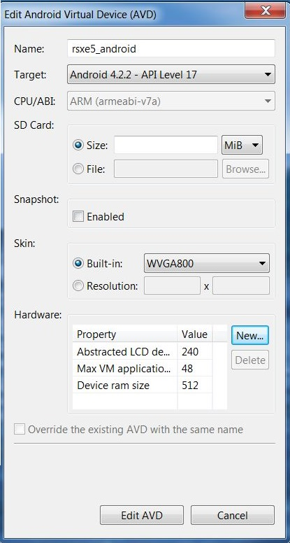

1. Add the **GPU emulation** property and set its value to **yes**:

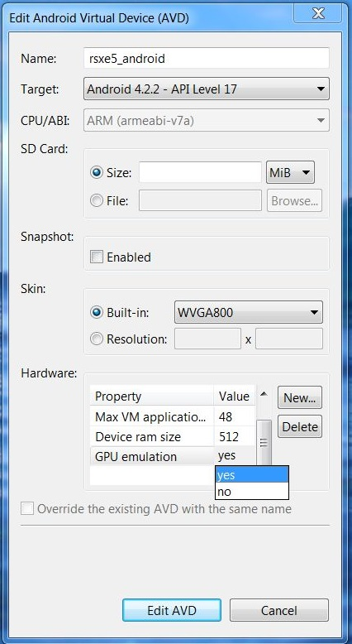

1. Click **Edit AVD** to save your changes.

To Start Your Android Emulator

1. Start the **Android Virtual Device Manager**:
   1. Select **Start > All Programs > Embarcadero RAD Studio > Android Tools**.
   2. In the **SDK Manager**, click the **Tools** menu and select **Manage AVDs**.
2. In the **Android Virtual Device Manager**, select your Android emulator in the list and click **Start**.
3. On the **Launch options** dialog box, click **Launch**:

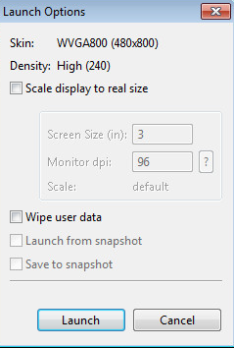

**Note:** If the **rsxe5_android** emulator is not present, you can create your own Android emulator. See [**Creating an Android Emulator**](https://www.embarcadero.com/starthere/xe5/mobdevsetup/android/en/creating_an_android_emulator.html)**.**

To Run Your Application on Your Android Emulator

1. Open your Android application in **RAD Studio**.
2. In the [**Project Manager**](http://docwiki.embarcadero.com/RADStudio/XE5/en/Project_Manager), enable the emulator as the target platform.

If necessary, expand the **Target Platforms** node and double-click the **Android** target platform. (The active target platform is displayed using a bold font.)

* 1. Expand the **Android** node in the Project Manager.
  2. Expand the child **Target** node.
  3. Double-click the target Android emulator to activate it. (The active emulator is displayed using a bold font.)

**Note:** If the emulator is not shown, right-click the **Target** node and select **Refresh**. If the emulator still is not displayed, see [Using the Target Node](http://docwiki.embarcadero.com/RADStudio/XE5/en/Target_Platforms_Overview#Using_the_Target_Node).

In the following image you can see the default **rsxe5_android emulator** running, and the target platform setting activated in the Project Manager:

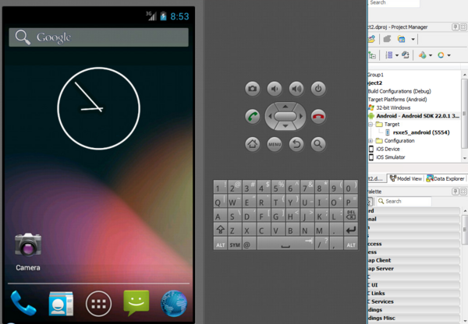

1. In the device selector in the **[FireMonkey Mobile Form Designer](http://docwiki.embarcadero.com/RADStudio/XE5/en/FireMonkey_Mobile_Form_Designer" \o "FireMonkey Mobile Form Designer)**, select the device that matches the emulator you are using. For example:
   1. If you are using the default **rsxe5_android** emulator with its built-in skin, select **WXGA800**.
   2. If your emulator uses the **WQVGA400** device, select **3.3" WQVGA Android Phone (240dp x 400 dp)**
2. Run your application:
   1. Run with debugging (**Run >**[**Run**](http://docwiki.embarcadero.com/RADStudio/XE5/en/Run) or F9)
   2. Run without debugging (**Run >**[**Run Without Debugging**](http://docwiki.embarcadero.com/RADStudio/XE5/en/Run_Without_Debugging) or Shift+Ctrl+F9)
3. Compile and deploy messages should appear in the IDE.
4. If the emulator is not running, the IDE displays: "The selected emulator is not running. Do you want start it?" Click **Yes**. A "Launching emulator" message is displayed.
5. Open your emulator screen and watch for the app to appear.

In the following image you can see a custom **Nexus 4** emulator running a simple **Hello World!** application:

